Colby O'Donnell

Lab 2 - Grep

Linux Admin CIS-245

October 18, 2023

**Get a Grep**

1. Print all lines containing the string Lane

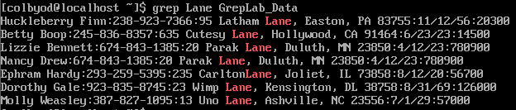

Using grep, we enter our search as “Lane” and the file we’re looking in as “GrepLab_Data”.

2. Print all lines where the person’s first name starts with H

**grep ‘^H’ GrepLab_Data.txt**

The ‘**^**’ indicates to start searching at the beginning of the line followed by the capital “**H**” giving the command to search for any line beginning with a capital **H**.

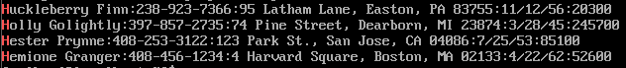

3. Print all lines ending in three zeros (000)

**grep ‘000$’ GrepLab_Data.txt**

The **000** (three zeros) tells the command what to look for and the following **$** tells the command to look at the end of each line in the file **GrepLab_Data.txt**



4. Print all lines that don’t contain 408



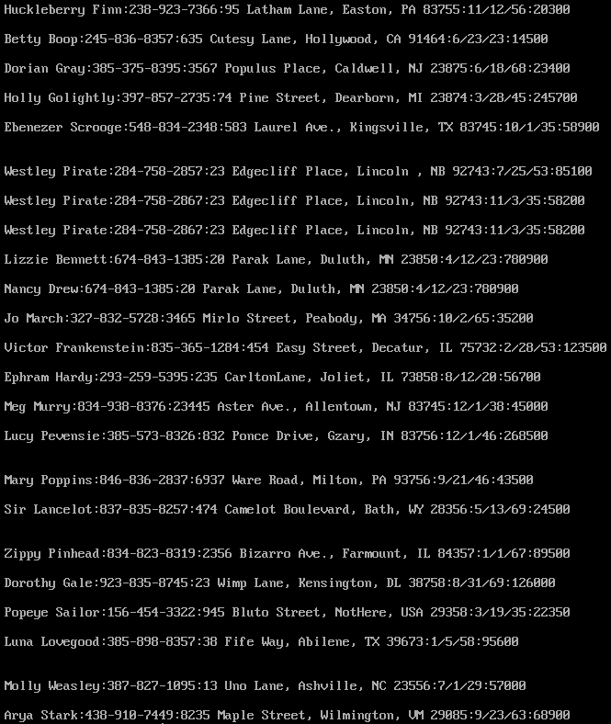

Here we use our command as well as the option **-v** as shown in the previous image to bring up anything in the file GrepLab_Data **without** the number **408** in any row of the file.

5. Print all lines where birthdays are in the year 1935 (be careful of the date format! it’s MM/DD/YY)

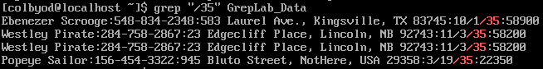

Being mindful of the birthday format, I use the “**/**” to search specifically in this part of each line in the text file as this is the only place that has that character. I then follow that with the number **35** to search for only the lines with that specific string of characters. It’s a bit of a loophole as there are only 12 months and up to 31 days. If the year requested were to end with **11** I would have to figure something else out.

6. Print all lines where the phone number is in an area code that starts with an 8

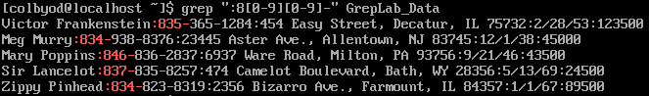

Here the command searches for the beginning of the area code with **8** then searches for any number between 0-9 twice but also including a hyphen to indicate that part of the row specifically.

7. Print all lines containing an uppercase letter, followed by 4 lowercase letters, a space and one uppercase letter. 1

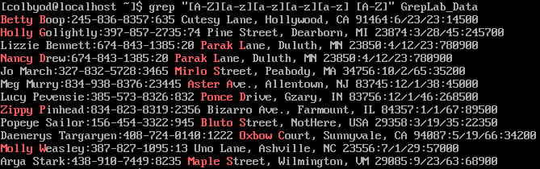

Using [A-Z] as a search we can find anything that begins with an uppercase then the following [a-z] searches for any lowercase letters in that order. Then a space in between the last [A-Z] to perform the same task.

8. Print lines where the address begins with a two or three digit number (so this would be 12 main st or 123 main street but not 1234 main street).

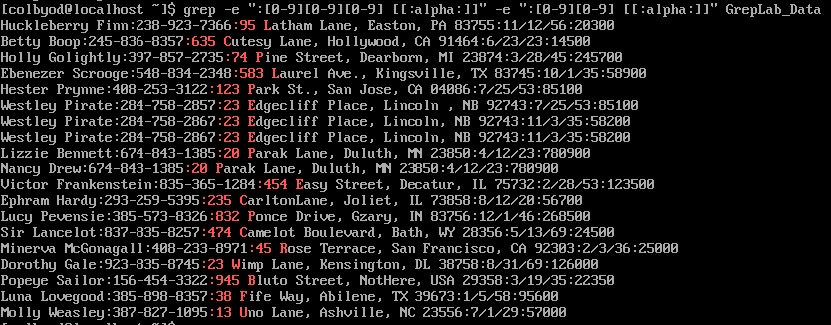

Using **-e** we can use additional commands to perform multiple searches in one command. [0-9] searches for a number so using three of those searches continuously will search for three numbers then the following [[:alpha]] searches for any letter in the alphabet. Stacking the commands next to one another using **-e** we now search for addresses that being with only two or three numbers.

9. Print lines where the person lives in Mass or Illinois

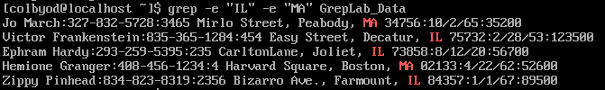

Using **-e** again we can search for both addresses in Illinois (IL) as well as Massachusetts (MA)

10. Print lines containing the addresses that aren’t on a street (You might see St as shorthand for street)

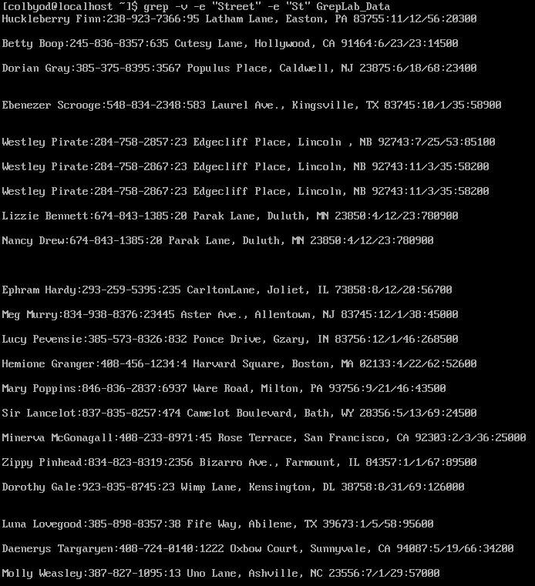

Using a combination of **-v** and **-e** we can exclude specific strings of “Street” and “St” simultaneously.